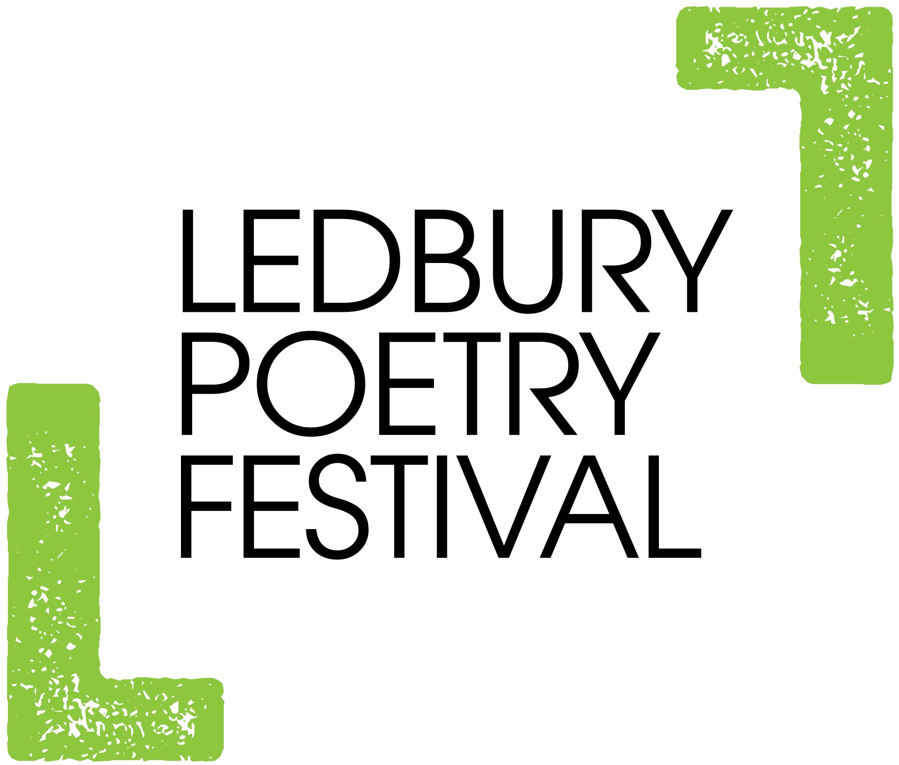
Volunteers – Ledbury, the Home of Poetry
Ledbury Poetry Festival and The Poetry House
Ledbury Poetry Festival couldn’t function without friendly and reliable volunteers to help during the Festival and now, with the launch of The Poetry House, throughout the year. Furthermore, as the way we work has changed, the Festival can now welcome volunteers to work both remotely, as well as in person.
The Festival is hugely appreciative of its volunteers and aims to provide a warm and encouraging environment where volunteers can pick up new skills and be fully involved.
Please tick next to activities you are interested to become involved in:
Helping to open The Poetry House throughout the year, welcome visitors
Stewarding workshops and events in person throughout the year
Stewarding workshops and events online throughout the year
Supporting the Poets in Schools programme, such as by assisting at events,
encouraging pupils to write, mentoring young writers
Office admin throughout the year - in person
Office admin throughout the year - remotely
Distribution of programmes
Box Office
Stewarding
Hospitality
Accommodation
Driving
IT support
Digital marketing/social media
Event managing
Other: (Give details below if there is anything specific you are interested in)

Skills Audit
Please list any and all skills you have that you might be willing to lend to Ledbury Poetry Festival and The Poetry House. Have fun with this exercise and aim to think out of the box!
Examples could include, baking cakes, posting on social media, sewing, excel spreadsheets, making cocktails, painting and decorating, scrabble, solving cryptic crossword puzzles!
We want to hear about anything you can do, no matter how random and seemingly unrelated to poetry! As Ledbury Poetry Festival becomes a more visible year-round operation based in a physical Poetry House, we aim to turn all our volunteers’ skills into assets!

Name: _________________________________________________________________
Address:________________________________________________________________
Tel: _______________________ Mob: _____________________________________
Email: __________________________________________________________________
Please return to director@poetry-festival.co.uk Ledbury Poetry Festival, The Poetry House in the Barrett Browning Institute, The Homend, Ledbury, Herefordshire

