Submission Form 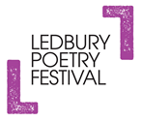
Ledbury Forte Poetry Prize – For Second Collections

Name of Publisher ___________________________________

Title Submitted:______________________________________

Name of Author ______________________________________

Year of Publication______________

I state that this publication is a book-length collection with a spine of 48 or more pages by a poet who has previously published a first book-length collection with a spine of 48 or more pages. I confirm that this publication has been published in the UK or Ireland in 2019 or 2020, and has not been published anywhere else first. I can confirm therefore that this publication fulfils the submission criteria for the Ledbury Poetry Prize.
I confirm that I am a director or the owner of this publishing house.

Signed __________________________________________

Name ___________________________________________

Date_____________________

