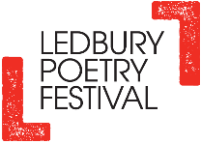
SEGMENTS, DECEMBER 2020 SESSION
EXERCISE ONE: Warm-up writing exercise – My Christmas Other Half
Inspired by Carol Ann Duffy's collection The World’s Wife - here is the poem, Mrs Midas https://www.scottishpoetrylibrary.org.uk/poem/mrs-midas/ - write a short poetic monologue in the voice of the spouse / partner / other half of a Christmas character, for example, Mrs Santa Claus, Mr or Mrs Pantomime Dame, Mrs Snowman, Mrs Rudolph Red-Nosed Reindeer or the spouse of any of the other reindeer, Mr Christmas Elf, Good Queen Wenceslas, Mrs Scrooge, Jackie Frost, one of The Three Wise Women, Mr or Mrs Shepherd…
You may want to write your poem on a Christmas card for someone!
EXERCISE TWO: The theme for this exercise is TEETH and DENTAL HYGIENE
Although Covid has had a serious impact on dental health this year, the most popular bestseller on Black Friday is the electric toothbrush. This workshop will explore the history of toothbrushes, toothpaste and dentures as inspiration for writing poetry.
Guide To The Slides:
Top row L-R Slide 1 - Toothbrush History – chewstick, manual toothbrush, electric
Slide 2 - The Horsehair toothbrush used by Napoleon Bonaparte (c1775)
Slide 3 - Photo from 1899 showing the use of a toothbrush
Slide 4 - 'Indexo' finger toothbrush, United States, 1901-19
Bottom Row L – R: Slide 5 - Various electric toothbrush heads
Slide 6 - Chewable toothbrushes
Slide 7 - Toothbrush and toothpaste

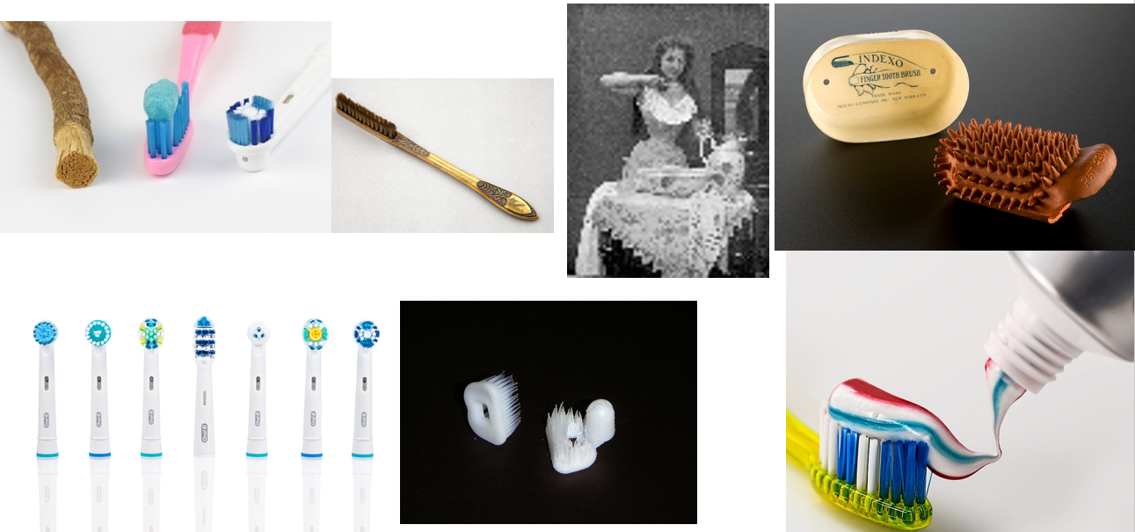
Next page:
Top Row L – R:
Slide 8 - Poster for glycerine toothpaste, 1889
Slide 9 - Poster promoting dental hygiene, 1936-38
Slide 10 - Carved ivory dentures from 18th century
Bottom Row L – R: Slide 11 - Waterloo Teeth
Slide 12 - Vulcanite denture with porcelain teeth and springs
Slide 13 - George Washington's dentures
Slide 14 - Modern dentures
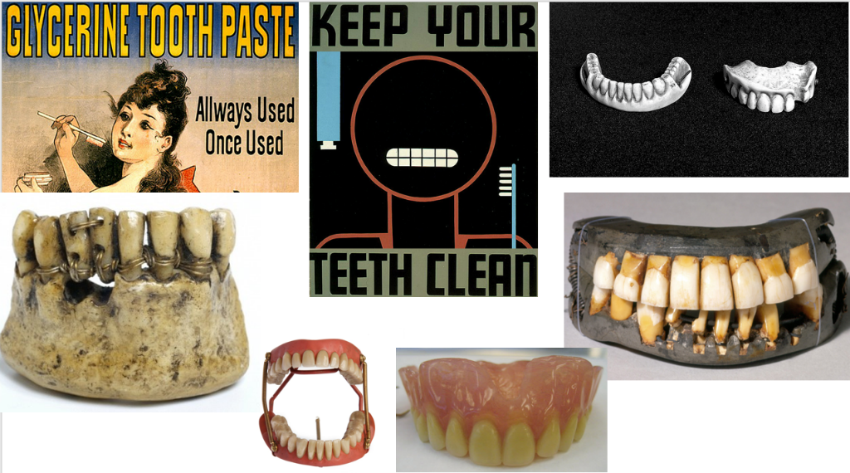
TOOTHBRUSHES
https://en.wikipedia.org/wiki/Toothbrush
https://www.loc.gov/everyday-mysteries/item/who-invented-the-toothbrush-and-when-was-it-invented/
Toothbrushes are available with different bristle textures, sizes, and forms. Numerous toothbrushes are made of plastic; such brushes constitute a significant source of pollution. Over 1 billion toothbrushes are disposed of into landfills annually in the United States alone. Bristles are commonly made of nylon.
History
Before the invention of the toothbrush, a variety of oral hygiene measures had been used. Excavations have recovered tree twigs, bird feathers, animal bones and porcupine quills.
The predecessor of the toothbrush is the chew stick. Chew sticks were twigs with frayed ends used to brush the teeth while the other end was used as a toothpick. The earliest chew sticks were discovered in Mesopotamia in 3500 BC, an Egyptian tomb dating from 3000 BC, and mentioned in Chinese records dating from 1600 BC. The Greeks and Romans used toothpicks to clean their teeth.
The first bristle toothbrush resembling the modern one was found in China. Used during the Tang Dynasty (619–907), it consisted of hog bristles. The bristles were sourced from hogs living in Siberia and northern China because the colder temperatures provided firmer bristles. They were attached to a handle manufactured from bamboo or bone, forming a toothbrush.
The bristle toothbrush spread to Europe, brought from China to Europe by travellers. It was adopted in Europe during the 17th century. The earliest identified use of the word ‘toothbrush’ in English was in the autobiography of Anthony Wood, a 17th century antique dealer, who wrote in 1690 that he had bought a toothbrush. Europeans found the hog bristle toothbrushes imported from China too firm and preferred softer bristle toothbrushes made from horsehair.
William Addis, an English entrepreneur, produced the first mass-produced toothbrush in 1780. In 1770, he had been jailed for causing a riot. While in prison he decided that using a rag with soot and salt on the teeth was ineffective and could be improved. After saving a small bone from a meal, he drilled small holes into the bone and tied into the bone tufts of bristles that he had obtained from one of the guards, passed the tufts of bristle through the holes in the bone and sealed the holes with glue. After his release, he became wealthy after starting a business manufacturing toothbrushes made of bone. He died in 1808, bequeathing the business to his eldest son. It remained within family ownership until 1996. Under the name Wisdom Toothbrushes, the company now manufactures 70 million toothbrushes per year in the UK.
Hertford Museum in Hertford, UK, https://www.hertfordmuseum.org/ holds approximately 5000 brushes that make up part of the Addis Collection, the largest collection of toothbrushes in the world. The Addis factory was a major employer in the town until 1996.
By 1840, toothbrushes were being mass-produced in Britain, France, Germany, and Japan. Pig bristles were used for cheaper toothbrushes and badger hair for the more expensive ones.
The first patent for a toothbrush was granted to H.N. Wadsworth in 1857 in the United States, but mass production did not start until 1885. The improved design had a bone handle with holes bored into it for the Siberian boar hair bristles. Unfortunately, animal bristle was not an ideal material as it retained bacteria, did not dry efficiently and the bristles often fell out. The ‘Indexo’ finger toothbrush was used widely in the United States. It was made entirely of rubber, and shaped to fit over the index finger. Brushing teeth did not become routine until after World War II, when American soldiers had to clean their teeth daily.
During the 1900s, celluloid gradually replaced bone handles. Natural animal bristles were also replaced by synthetic fibres, usually nylon, in 1938. The first nylon bristle toothbrush made with nylon yarn went on sale on February 24, 1938. The first electric toothbrush, the Broxodent, was invented in Switzerland in 1954.
A chewable toothbrush is a miniature plastic moulded toothbrush which can be placed inside the mouth. While not commonly used, they are useful to travellers and are sometimes available from bathroom vending machines.
TOOTHPASTE
https://en.wikipedia.org/wiki/Toothpaste
https://stetsonhillsdentist.com/the-history-of-toothpaste/
Humans have used many different concoctions to clean their teeth over the years. However, it’s only been in the last 100 years or so that our version of toothpaste has been in existence.
History
The first civilization that historians have documented using a toothpaste-like mixture to brush their teeth is the Egyptians as early as 5,000 BC. Their first recorded formula dates back to 4 AD. Their mixture contained:
• Crushed rock salt
• Mint
• Iris flowers
• Pepper
This formula caused lots of irritation and gum bleeding, though in terms of effectiveness, it cleaned teeth remarkably well.
Some formulas featured crushed bone and oyster shells such as in Greek and Roman societies, and ginseng, herbal mints and salt in Chinese cultures. Ancient humans also used ingredients that included ox hooves, pumice, brick dust, burnt eggshells, ashes, chalk and pulverized charcoal.
In more recent centuries, toothpaste continued to evolve:
• 1780: Evidence shows people used burnt breadcrumbs to brush.
• 1824: A dentist named Dr. Peabody added soap to abrasive ingredients for more cleaning power. Later on, soap was replaced by detergent for a better-blended consistency. This was the turning point from tooth powders to a more paste-like texture.
• 1850’s: Chalk was used in oral hygiene for the next few decades.
• 1873: The first smooth, good-smelling paste is created by Colgate and sold in tiny glass jars.
• 1900 A paste made of hydrogen peroxide and baking soda was recommended for use with toothbrushes.
• 1914: Fluoride is added to toothpastes after studies show its many benefits to teeth.
• 1987: Edible toothpaste is invented by NASA for astronauts to brush in space without spitting.
• 1989: The first toothpaste marketed as “whitening” is sold by Rembrandt.
DENTURES
https://silveradofamilydental.com/true-history-false-teeth/
https://en.wikipedia.org/wiki/Dentures
https://www.theguardian.com/artanddesign/gallery/2018/may/05/three-hundred-years-of-false-teeth-in-pictures
Until very recently, “false” teeth were often not false at all, but rather real teeth taken from another human or animal.
History
The earliest record of dentures dates from around 7th century BC, when Etruscans fashioned dentures from animal and human teeth fastened together with gold bands. This art ended with their civilization, but re-emerged with the practice of making dentures in the 1700s.
Wooden full dentures were invented in Japan around the early 16th century. Softened bees wax was inserted into the patient's mouth to create an impression, which was then filled with harder bees wax. Wooden dentures were then meticulously carved based on that model.
In the 1700s, sugar was well-known and available throughout Europe. As a result, there was more tooth decay. Many people had missing teeth, and it was rare for someone to reach 50 with all their natural teeth.
Although our modern technology allows for comfort and easy-to-use dentures, this was not always the case. Original dentures had difficulties with fit, attachment, comfort, and durability. As dentists tried to improve false teeth, they tried many different materials and techniques:
Ivory
Ivory was one of the earliest materials used to replace lost teeth. Ivory came from animals like the hippopotamus, walrus, or elephant. These teeth tended to decay and rarely looked natural, but got the job done.
Waterloo Teeth
The best dentures were made from human teeth. The source of these teeth ranged from robbed graves, peasants looking to make a quick buck, and even dentists’ collections. Understandably, these sources provided poor quality teeth. Their poor quality meant that dentures were mostly cosmetic and needed to be removed for eating.
Gruesomely, the death of 50,000 men at the battle of Waterloo in 1815 soon helped to address the lack of quality human teeth. Soldiers marching at Waterloo were young and healthy, so their teeth were ideal for denture making. Teeth were extracted after men died on the battlefield. “Waterloo teeth” became the fashion in Britain and were often worn as a trophy despite the impossibility of knowing their direct origin. This practice of using human teeth for dentures continued into the late 1860s.
Vulcanite
Luckily, such ghastly techniques lessened after 1843 when Charles Goodyear discovered how to make flexible rubber. Charles’s brother Nelson named the new material vulcanite and patented it in 1851. It turns out that vulcanite makes a more comfortable base for false teeth. Because other versions of false teeth were more expensive, the market for vulcanite teeth flourished. For the first time ever, middle class people bought and wore false teeth along with the rich and wealthy.
Porcelain
Porcelain false teeth were invented in the late 1700s in France. However, their tendency to crack and grate against each other made them unpopular choices. It wasn’t until after many improvements in strength and texture in the late 1800s that porcelain teeth became a popular choice for dentures and bridges and replaced human teeth, ivory, and bone.
Here are two public figures with interesting dental history:
Queen Elizabeth I
Problem teeth were extracted but few attempted replacements with substitute teeth, and the procedures often went awry. If aching teeth remained, further decay would occur with no replacement alternative. During Elizabeth's 44 year reign from 1558-1603, ivory dentures had not yet been developed. The only solution available to her was stuffing bits of cloth into the gaps in her teeth when attending public events.
George Washington
Despite popular legend, George Washington’s teeth were not made of wood. Instead, Washington commissioned several dentists throughout his life to fashion false teeth out of the finest materials available. George began to lose his teeth to decay when he was 22 and had only one tooth left by the time he became president. The dentures he purchased to replace his teeth were the most scientifically advanced of the time, but in the late 18th century, that didn't mean much. They didn't fit well, which caused him pain, and made it difficult to eat and talk. Dr. John Greenwood of New York fashioned a set of false teeth out of hippopotamus ivory held together with gold springs for the president’s inauguration in 1789.
Prior to this, he had a set made with real human teeth that he purchased from "several unnamed slaves" in 1784. The base that fit the fake teeth into the jaw was made of lead. The top teeth were sourced from horses or donkeys, and the bottom were from cows and the mouths of unknown people. These teeth actually deteriorated themselves, revealing the wire that held them together. The dentures open and shut thanks to metal springs, but because they were controlled by springs, if he wanted to keep his mouth shut, Washington had to permanently clench his jaw.
Modern Dentures
Luckily for us, the 20th century yielded new technologies and materials for dentures. Acrylic resins and other malleable plastics are now the norm for denture and bridge partials. Plastics are easy to get and manipulate, so the price of dentures is also considerably lower. Dental advancements also came about regarding the fit and suction of false teeth. Modern false teeth and dentures are more comfortable, are easier to chew with and last longer than teeth made with past materials.
Now look at the following poems:
Tooth – Martha Sprackland
https://tankmagazine.com/tank/2018/12/milk-tooth/
https://www.telegraph.co.uk/books/what-to-read/poem-week-tooth-martha-sprackland/
The poem imagines a sore tooth as 'a sealed world seething/ like a black egg'. Martha Sprackland's poem is about the agony of toothache. Poets usually deal in intense feelings: love, loss, remorse. But in this poem from her Forward Prize-nominated debut Citadel, Martha Sprackland captures a kind of pain that can be just as intense and all-encompassing, but which almost never turns up in poems – toothache.
A tiny “clamorous point” becomes the centre of the world. The nagging "aw" rhymes (jaw, sore, raw) at the end of each stanza create a sense of being trapped, without any escape from the agony. At one point, the poet breaks the pattern to cry "I want it out!" – but the aching rhyme is back in the very next stanza. Even her lover, with his "skin like cotton, outside the pain", can't offer her a reprieve. (Tristram Fane Saunders - The Telegraph)
Wisdom Teeth – Daisy Bentley
https://powerpoetry.org/poems/wisdom-teeth
Oh, I Wish I’d Looked After Me Teeth – Pam Ayres
https://monologues.co.uk/Pam_Ayres/My_Teeth.htm
EXERCISE THREE: Get Your Teeth Into Poetry
Write a poem inspired by the items we've explored, items you may have and/or the theme. Here are some suggestions for ways in to the writing:
Write a personification poem from the point of view of an object (eg: a tooth; milk tooth; toothbrush; dentures...) Write your poem imagining the object is ‘alive’ and has the same attributes as a human being. What would it say? Think about the function of the object, where it is situated, what it sees, smells, hears, tastes, touches. What does it think about/dream about? Memories? Opinions?
Write a poem inspired by the theme that evokes a personal memory for you, maybe involving another person or a personal story, eg: teaching children to clean their teeth; the tooth fairy; someone who wore or wears dentures
Write an ode to an object – a poem in praise of an object, eg: a toothbrush, toothpaste, dentures; a thank-you poem – taking into account its function, how it makes you feel, what it can make you do. Praise details about what it looks, feels, smells, sounds, tastes like etc.
Maybe use a poetic form or style from the poems you've looked at, eg: the different uses and function of rhyme (Tooth - rhyme creates tension; Oh I Wish I'd Looked After Me Teeth - rhyme used for comic effect and to tell a story ); personification (Wisdom Teeth); imagery to create a particular mood (Tooth and Wisdom Teeth); verse structures (Tooth and Oh I Wish I'd Looked After Me Teeth); no verse breaks, centred format (Wisdom Teeth)
And, of course, you may write a poem about the items and/or theme in your own way and in your own style!
©Sara Jane Arbury

The Festival is grateful to Arts Council England and the Garfield Weston Foundation for supporting the Festival's Community Programme


