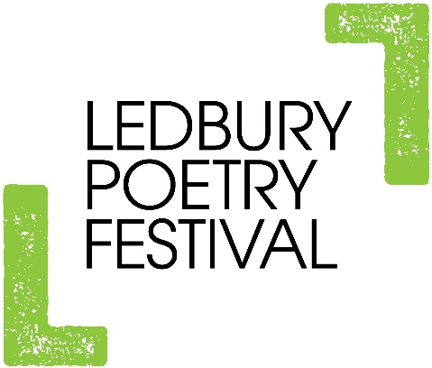

LEDBURY POETRY FESTIVAL
EVENT MANAGERS’ TRAINING DAY
Wednesday 18 March, 2020
The Panelled Room at The Master’s House,
Bye Street, Ledbury HR8 1EA
9.15am for 9.30am – 1pm followed by complimentary lunch
FREE to attend, but MUST book place

Meet famous performers! Improve your skills! Learn what it takes to be an event manager for the Festival, with fun and light hearted activities. This is a great day for both new and experienced event managers. Come along even if you are just interested to see what it entails.

Remember: event managing does not necessarily include introducing the event! You can event manage without having to speak in front of a crowd!
http://www.poetry-festival.co.uk/volunteers/

Places are limited. Book by Weds 11th March, giving any dietary restrictions
Phillippa: manager@poetry-festival.co.uk
01531 636232

