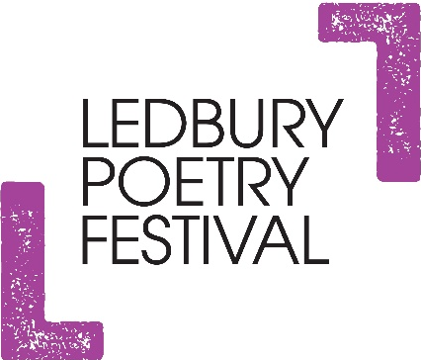

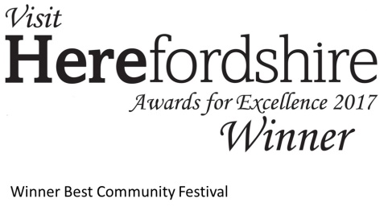

LEDBURY POETRY FESTIVAL
EVENT MANAGERS’ TRAINING DAY
Wednesday 13 March, 2019
The Panelled Room at The Master’s House,
Bye Street, Ledbury HR8 1EA
9.15am for 9.30am – 1pm followed by complimentary lunch

Meet famous performers! Improve your skills! Learn what it takes to be an event manager for the Festival, with fun and light hearted activities. This is a great day for both new and experienced event managers. Come along even if you are just interested to see what it entails.

Remember: event managing does not necessarily include introducing the event! You can event manage without having to speak in front of a crowd!
http://www.poetry-festival.co.uk/volunteers/

Places are limited. Book by Weds 6th March, giving any dietary restrictions
Phillippa: manager@poetry-festival.co.uk
01531 636232
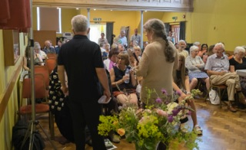
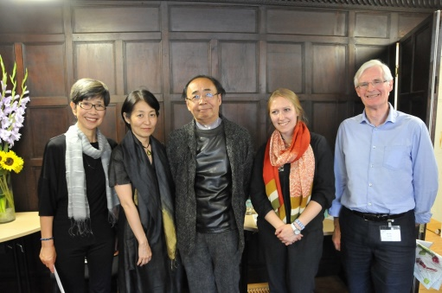
Angela France with Ian McMillan at the Poetry Competition Winners' event
Alan Lloyd with Mikiro Saski and Masayo Koike

