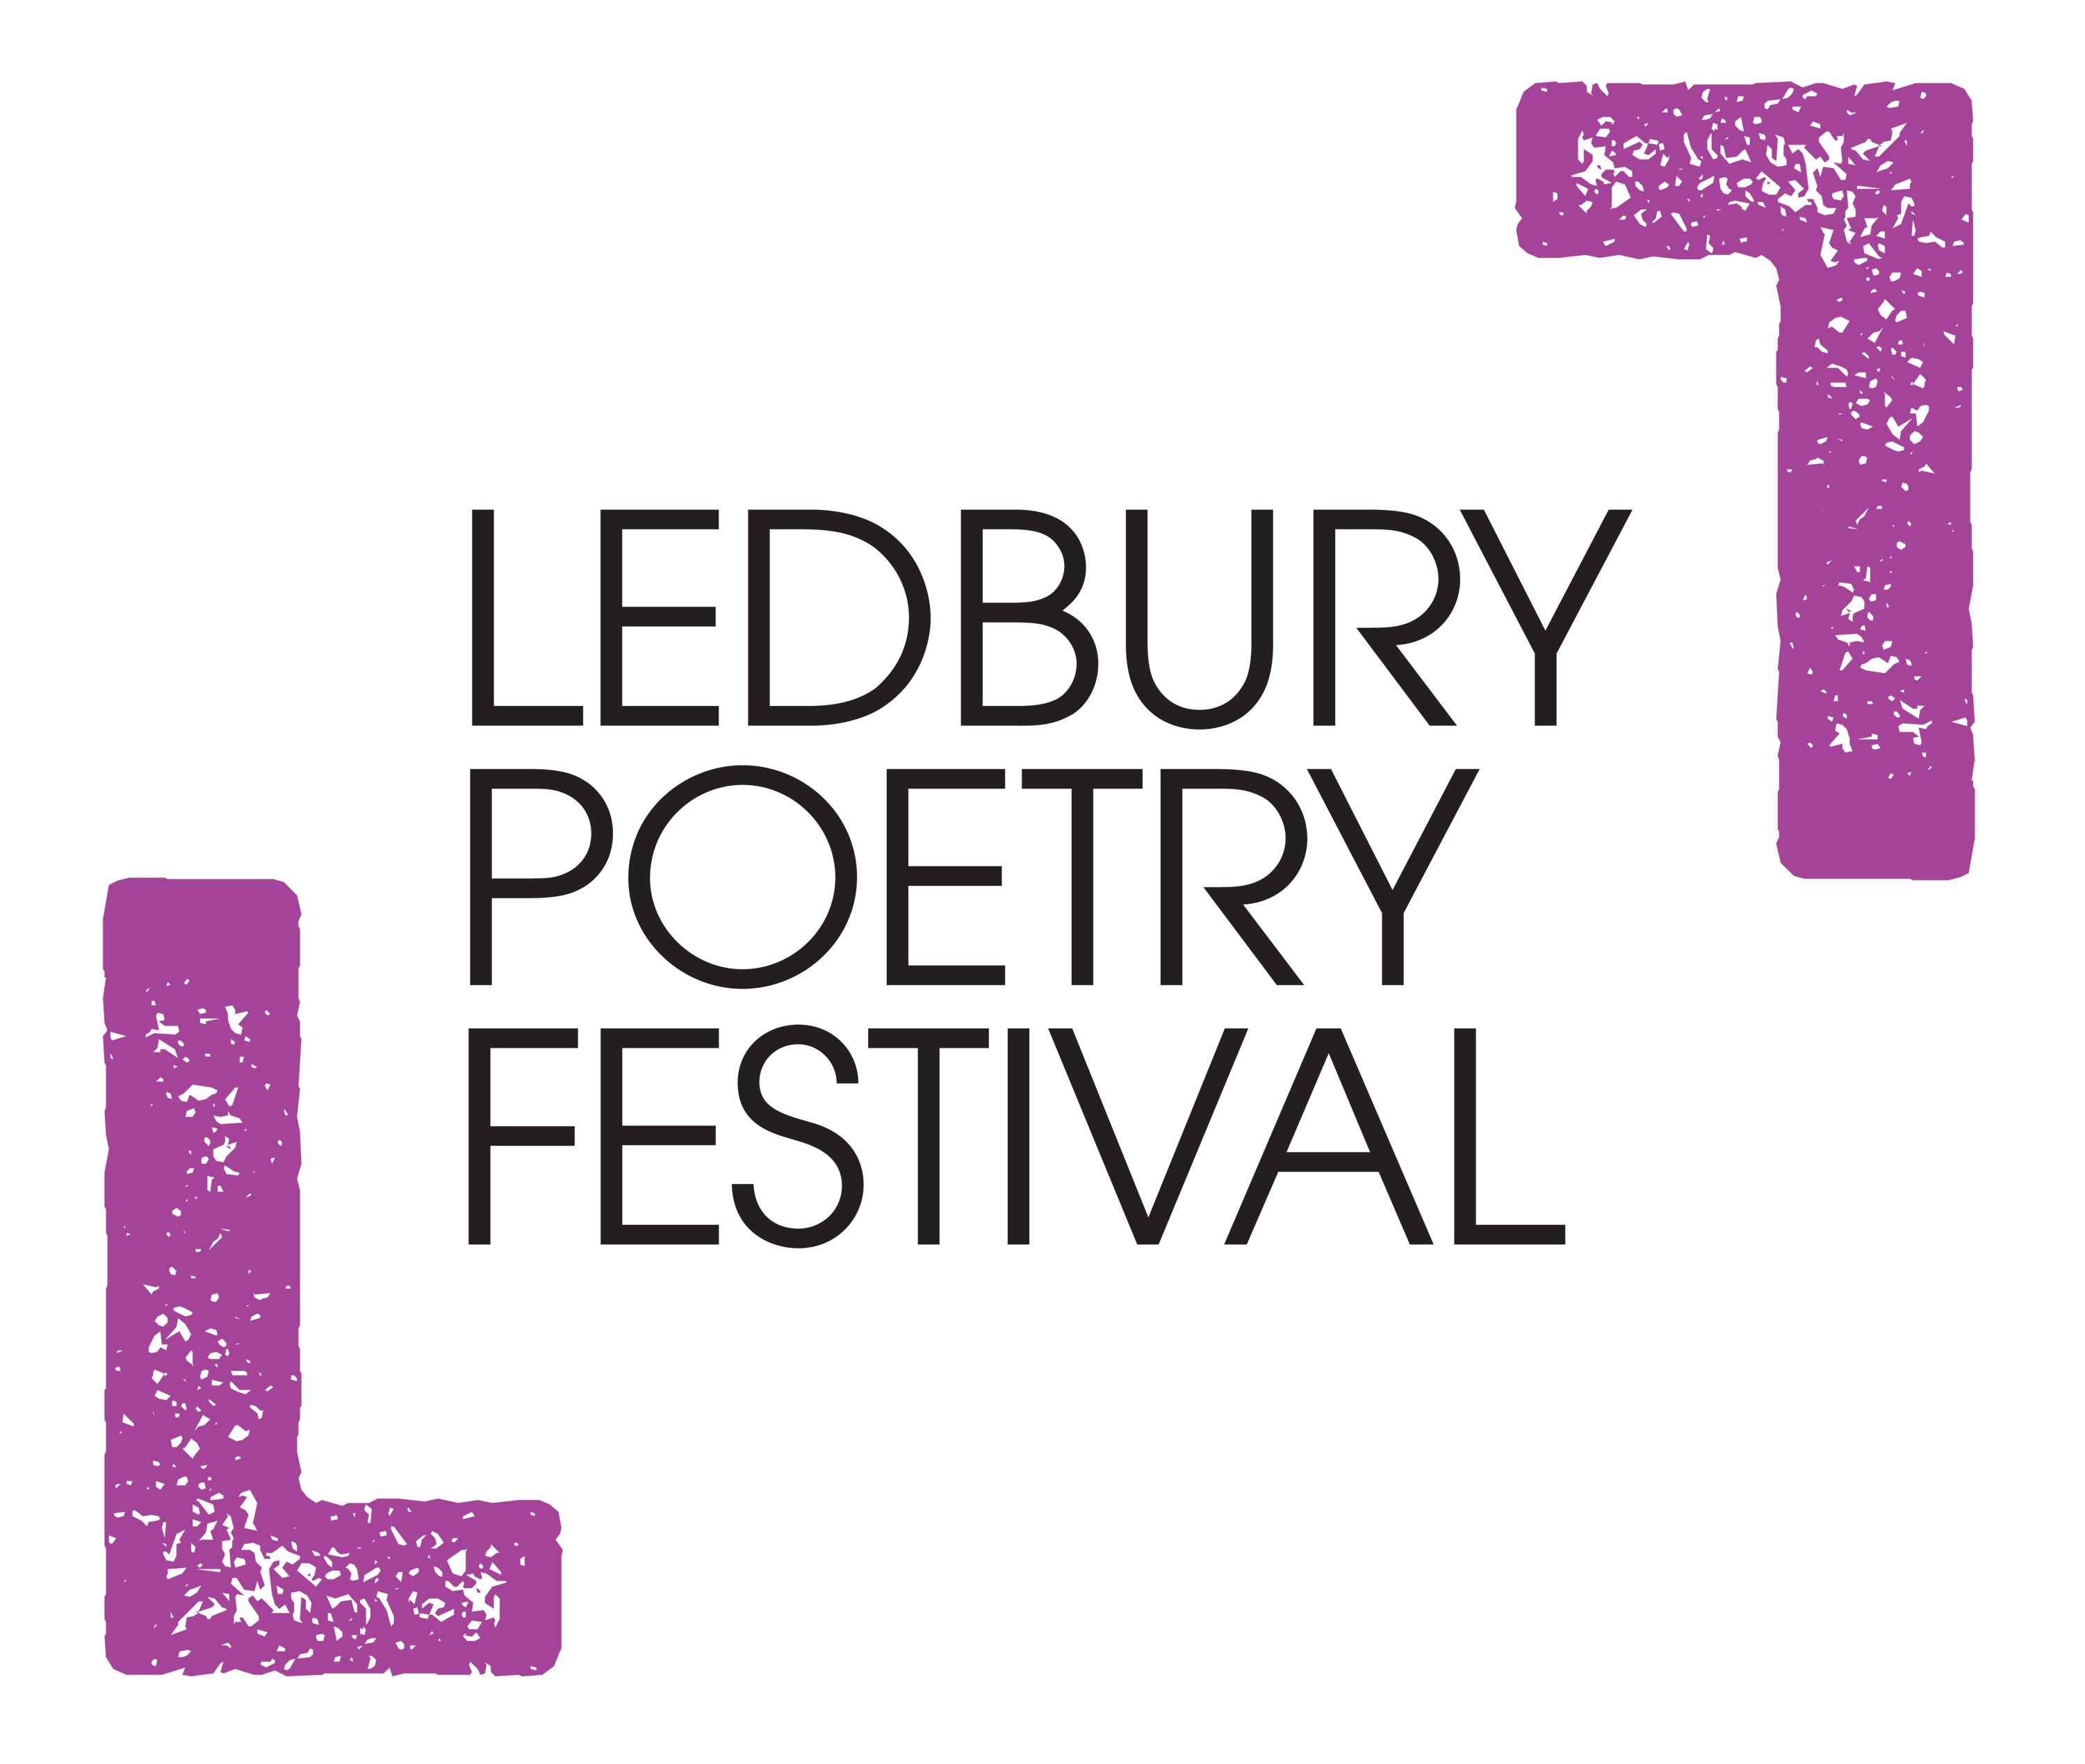
Ledbury Forte Poetry Prize – For Second Collections
Ledbury Poetry Festival is pleased to announce the second edition of the Ledbury Forte Poetry Prize for second collections published in Britain and Ireland in 2017 and 2018. The Judges are Lachlan Mackinnon and Linda Gregerson. The deadline for publisher submissions is Tuesday 30 October 2018 (books published in November and December 2018 can be submitted in proof form if necessary). Publishers should send three copies of each second collection to Chloe Garner, Ledbury Poetry Festival, The Master’s House, Bye Street, Ledbury HR8 1EA. One copy will be sent to each judge and one copy kept by Ledbury Poetry Festival for reference and publicity purposes.
This prize aims to support and encourage poets at the ‘mid-career’ stage, with a shortlist and a prize of £5000 for the winning second collection. In assessing the shortlisted second collections, the judges will also read the poets’ first collections and take account of how their work has developed from debut to second book. The shortlisted poets will be invited to read at a Prize Giving event on Friday 5 July 2019 at Ledbury Poetry Festival when the judges, Lachlan Mackinnon and Linda Gregerson will announce the winner.
The first winner of the prize, covering second collections published in Britain and Ireland in 2015 and 2016, was Sandeep Parmar for Eidolon and the judges were Tara Bergin and Vahni Capildeo. The shortlisted poets were Judy Brown for Crowd Sensations (Seren), John Clegg for Holy Toledo! (Carcanet), Emma Hammond for The Story of No (Penned in the Margins), John McCullough for Spacecraft (Penned in the Margins), Sandeep Parmar for Eidolon (Shearsman Books) and Sam Riviere for Kim Kardashian’s Marriage (Faber & Faber) all of whom were invited to read at Ledbury Poetry Festival.
A successful publicity campaign for the prize in its inaugural year led to features in The Telegraph, which praised the shortlist and the prize for highlighting the importance and difficulty of writing a second collection, as well as The Bookseller, PN Review, Poetry News and extensively online. Tom Chivers, Editor at Penned in the Margins wrote, “Why must a poet's 'difficult second album' be difficult? No: it can be dangerous, risk-taking, liberating and wildly ambitious. I welcome a new prize for second collections, to shine a spotlight on work that might otherwise fall down the gap between the excitement of the new and the confidence of the established.” According to The Telegraph “The Ledbury Forte Prize is the first of its kind: a biannual award for follow-ups, with a £5,000 purse. One might argue that the solution to prize culture’s problems isn’t more prizes (why not a gong for third collection, too?) but the Forte’s thrilling shortlist will silence the critics. Avant-garde and “conventional” lyrics rub shoulders. It feels dangerous, in the best way possible.”
At the moment Ledbury Poetry Festival has funding to run the prize for 2019 and 2021, after which the aim is to raise more funding. Eligible second collections will be book-length collections by poets from Britain and Ireland who have previously published book-length first collections.
SUBMISSION GUIDELINES
All books submitted must fulfil the entry guidelines
1. Publishers should send three copies of each submitted second collection to Ledbury Poetry Festival no later than 30 October 2018. (Books published in November and December 2018 can be submitted in proof form if necessary).
2. Books must have been published in the UK or Ireland in 2017 or 2018, and cannot have been published anywhere else first.
3. A second collection is defined as a book-length collection with a spine of 48 or more pages by a poet who has previously published a first book-length with a spine of 48 or more pages.
4. The submission form must be signed by a director or owner of the publishing house.
5. A shortlist of six titles will be drawn up by judges Lachlan Mackinnon and Linda Gregerson and announced by LPF on Thursday 4 April 2019. At this point, LPF will ask the publishers of the six shortlisted collections to send up to three copies of the poets’ first collections, or will seek to obtain copies for the judges if the first collection was issued by a different publisher.
6. The poets on the shortlist will be invited to read with the prize judges at an event on Friday 5 July 2019 at Ledbury Poetry Festival when the winner of the prize will be announced and the winner’s cheque for £5000 will be presented.

JUDGES BIOGRAPHIES:
Lachlan Mackinnon
Lachlan Mackinnon lives in Ely. He is the author of five collections of poems including Small Hours, shortlisted for the Forward Prize for Poetry in 2010, and works of criticism and biography. His most recent collection Doves was published by Faber in 2017. He writes academically in English and French about Shakespeare and modern English and French literature. He is a regular reviewer for the national press, and received a Cholmondeley Award in 2011.

Linda Gregerson
Linda Gregerson is the author of six collections of poetry, most recently of Prodigal: New and Selected Poems (Houghton Mifflin Harcourt 2015). Among her earlier books, Magnetic North (2007) was a finalist for the National Book Award; Waterborne (2002) won the Kingsley Tufts Poetry Award; The Woman Who Died in Her Sleep was a finalist for both the Lenore Marshall Award and The Poets Prize. Gregerson has also received awards from the American Academy of Arts and Letters, the Poetry Society of America, the Modern Poetry Association, the Guggenheim Foundation, and the National Endowment for the Arts. Gregerson teaches at the University of Michigan, as Distinguished University Professor of English and Creative Writing, and is also a Chancellor of the Academy of American Poets. She divides her time between London and Ann Arbor.
