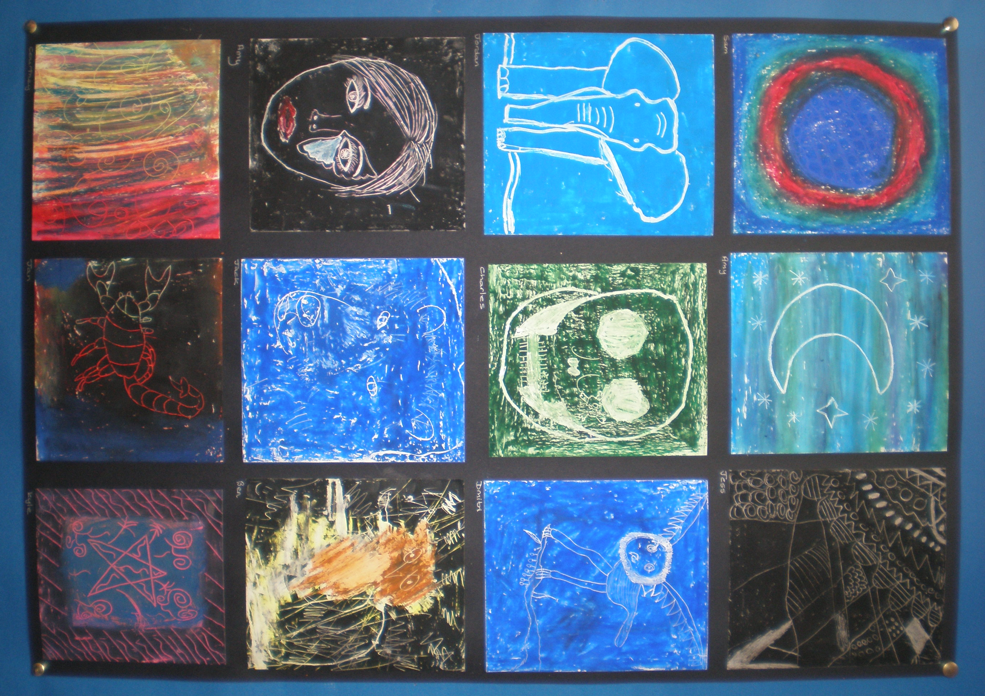

White Tigers, Red Stripes
An Anthology

White Tigers,
Red Stripes

The Aconbury Centre

copyright © 2016 The Aconbury Centre

The moral rights of the author have been asserted.

All rights reserved. No part of this publication may be reproduced, distributed, or transmitted in any form or by any means, including photocopying, recording, or other electronic or mechanical methods, without the prior written permission of the publisher, except in the case of brief quotations embodied in critical reviews and certain other non-commercial uses permitted by copyright law. For permission requests, write to the publisher, addressed “Attention: Permissions Coordinator,” at the email address below.

Cover layout and formatting
Miss J. Baggott
All enquiries to ks3admin@hprs.hereford.sch.uk

First published 2016

Introduction:
The following poems are the result of several workshops funded by The Ledbury Poetry Society, allowing the students of The Aconbury Centre to work and write alongside the internationally renowned poet, Joelle Taylor.

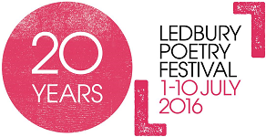

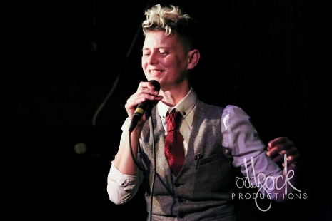

Joelle Taylor
Joelle Taylor is a spoken word artist, poet, playwright, author and cultural terrorist. She has performed across the UK as well as internationally for the British Council (Zimbabwe, Brazil, Botswana) taking in a diverse range of venues from Dingwalls, the 100 Club, the 02 Arena, the Royal Festival Hall and Ronnie Scott’s to the Royal Court, the Globe, the ICA, Buckingham Palace and both Pentonville and Holloway prisons.

To Mrs Dixon
For always seeing the best in people.

Contents

17,301 7
Freedom 8
These Kids 9
Pencil Sharpeners 10
I Wondered How He Knew 11
How I Feel 12
My Mother Named Bullets 13
Cold 14
You Are Not Alone 15
Branches 16
Writing Poetry on Skin 17
No Hope 18
Lost Souls 19
Real men 20
The Warning Bells 21
Flight Paths 22
Lost 23
Skin City 24
Respect 25
Gang Sign 26
Spinning Through 27
City Man 28
The Wings 29
This is a Poem to Save 30
Feed Them to the Lions 31
White Tigers, Red Stripes 32
Roof lights 35
Teachers 36

17,301

His eyes were broken bottles on the floor
And his legs were the stocks of rifles
His skin was burnt ashes from his flaming home
And his breath was the sound of fighter jets flying over his village
His head was a bomb buried, ticking
And his fingers the rows of refugees escaping
His face was bruised with black soot
And his voice screams, silent sirens
His laugh was a sniper tower rapid firing
And his tears were the sea that the refugees sailed across,
The ocean claimed him.

By Ben Evans and Jessica Quinn

Freedom

Freedom is a small boy
on a desert island,
floating in the middle of a grey council estate.
The sirens in the distance
are the song of tropical birds;
The shadow of drones on the concrete.
Graffiti is the corrupted roots of trees,
and people’s faces are flowers.

Rubbish blown across the empty roads are the shades of fish:
Freedom is a small boy
In a small flat, with the greatest wish.

James Brown, George Perkins and Jack Bullock

These Kids
These kids
Who think they’re hard,
Just because they have been barred.
Whose clothes are bigger than their hearts.
These kids
Who sit alone, trapped in their bodies,
Head eaten by grey hoodies,
Who think they are ugly,
Targeted by bullies,
Drift apart like separate countries.
These kids
Who hate other people’s skin,
And treat different races like garbage in a bin,
Who spit on people with different origins.
These kids
Waiting to change their lives,
But their smiles are sharpened edges of knives,
Deep inside they are just trapped children:
Hold out your hand: help them to freedom.

Martin Aunins and Dylan

Pencil Sharpeners
I got bullied and mistreated
I was upset and receded;
I could never face the real world,
Freedom was all I needed.
The pills came flowing and I couldn’t take much more,
I wanted to die.
I wanted to fly high with the angels in the sky,
They’re happy right?
She was gone.
We are now neither friends nor enemies,
We are simply strangers with some memories
But I was the one alone…
Razor, knife, scissors,
Pencil sharpener,
Scars and cuts everywhere.
They destroyed me.
I couldn’t feel the people who loved me,
I could only feel the hate for myself like everyone else felt, for me.

Eden

I Wondered How He Knew

I wondered how he knew what I was feeling?
The pain that was stabbing me needed healing -
My bleeding heart that no one else could see,
But I felt that he could see the real me,
Everyone else treated me aggressively:
I was the lone victim of much older bullies.
But this man
Held his hand to me,
Gave me a pen,
And set me free,
To be who I wanted to be,
No one else could see:
But he let me be me.

Jordan Stevenson

How I Feel

Why do they call me names?
They think it’s funny.
They punch me, kick me.
Why are they nasty to me?
I sit at home thinking
It would be better if I wasn't here.
All of my family say leave it -
But I can’t.
I walk out of my house thinking
What if I'm not here tomorrow?
What about my close friends?
Thinking I will be in heaven soon,
I sit at home begging in my room.

Just leave me alone.

This is how I feel.
Empty inside.
Stabbed in the heart.

Courtney Gardner

My Mother Named Bullets
My mother named bullets,
Shot my friend,
She didn’t want him around again:
Rude, ignorant, not good enough,
My friend thought that he was tough.

He, horrified dived to the floor,
Crawled on his belly out the front door,
But my mum filled with rage, aimed,
Out the window, blowing blood,
And let off shots across the neighbourhood.

That will teach him
To do the washing up.

George Perkins

Cold

Silent,
Dark,
Cold,
The city streets are cold,
For you the streets are full of people,
Friends, family,
But for them,
The homeless,
The streets are,
Silent,
Dark,
Cold,
They are alone, alone in this cruel world,
No one to help, to protect,
No food, No money,
No bed, No money,
What is money?
Money is the downfall of the world,
People who can’t earn money,
Who don’t have money?
The world is forever,
Silent,
Dark,
Cold.

Sam Elms-Lester

You Are Not Alone

Every one of these tower blocks is a book.
Every window is a new beginning.
Started at the bottom,
Now we’re constantly winning.

The streets below are stained with graffiti,
A passion for art,
In the dark broadcast on CCTV.

Little Red Riding Hood,
A concealed gun under her cloak of blood.
Every story is an open mind,
The holes in the ground that the bullets left behind.

Skinny gangs of lions roar
From the tops of derelict tower blocks,
Calling for their homes,
Turning their streets into war zones.

Martin Aunins

Branches

My mother named bullets
After all the people that hurt her.

A new knife in her back for everyone,
Because true friends stab you in the front.

A new scar on her arm for every day’s pain.
A new tear on her face to wash it all away.

Like a bird on a branch,
But when the branch snaps,
The gun fires and the bullet
is
gone.

Ruby

Writing Poetry on Skin

I used to write poems and burn them;
Throw them off the edge of a bridge instead of myself.
Making each day pass by smoking drugs found on lonely roads,
And stealing the alcohol you find in so called homes.
Frustrated on the streets with your fists
Never knew later it’d turn into knives;
Seeing your brother bleeding on the ground
Trying to hold back time;
but you know this time it’s over for good.
You end up going out
Trying to sort your life out
But he’s there again:
Beating her up.
All of it comes out, you go in for the kill
But you wake up:
You’re in hospital.
In the dark hours of the night you leave
Trying to find your lost soul in the sky,
But they track you down.
It happens again,
Fourth time now,
But this time you’re bleeding.
You’re smoking the rocks again
So you go forever trying to feel alive,
Writing poems in the dark blue sky
Burning them off bridges.

Jessica Quinn

No Hope

She extends her wings made out of fire
And propels off of the building,
All of her old memories
Burning slowly
As she descends

Trying to push through
Is one good memory;
That one memory,
Made her wings stretch and fly
She now has hope,
Whilst praying for her life,
Waiting for the last fight of her life

Ben Evans

Lost Souls

This is for the lost souls who cry to be noticed -
And not to be toast in horror films -
Filled with egos and arrogance.
This is for the depressed child who is hugging a teddy, crying alone.
This is for the caring older sister,
Who is always looking after a younger sibling.
This is for the loving single mother,
Who always struggles,

And will do everything to protect her child.
Dmitri

Real men

My mother named bullets,
Brought me up in a gang -
Said it would make me stronger,
A real man.
So she dressed me in black,
Gave me a gun and told me to attack,
The man next door for his Apple Mac,
Then she dug a trench around our flat,
Aimed a machine gun at our cat -
Who was wearing a backwards baseball cap -
But my cat had flick knives in his paws,
My living room became the site of the Third World War

Jack Bullock

The Warning Bells

Each kiss was like an invading country,
This boy haunted me wouldn't let me be free,
Wouldn't accept that I had met someone else,
And soon I heard the warning bells.

He watched me walking through the town,
Staring through the windows when the lights were down;
And one night my sleep was broken by a massive bomb -
I leapt out of bed but he was gone.

I drifted back to dreams grateful to be alive.
And woke to him standing over me with a shining knife
and I was gone
drifting
in
heaven.

Courtney Gardner

Flight Paths

She extended her black wings of sorrow and jumped
But she didn’t fall to her end -
She flew across the tower block
Looking into the darkened windows filled with hatred and fear
Then she realised she wasn’t the only one with the black wings of sorrow.

They left together
Mending their wings to feel the joy again

Jessica Quinn

Lost

I was alone, crying on the stairs
Wondering if anyone cared
Thinking if my mum was okay
Wondering if she’d got away.

He was back again,
The man we used to call a friend -
Accusing my mum of stealing,
Then he kicked her until she was bleeding.

He threatened to burn our house down,
We had to move to a different part of town.
I wondered why I had to watch my dad beat my mum,
Thinking I was dumb,
Then we escaped to a women’s refuge
He still wanted to see me, but I refused.
Then everything was ok.

Courtney Gardner

Skin City

He has cities in his skin.
A dark pitiless void in his heart,
And sad frozen over eyes watching a closed door.
Waiting for a noise,
A person,
Who can fill the void,
Warm the ice,
Make the cities have light and cheer;
Yet he knows that no one will save him,
From his pit of cushions,
Slowly filling with tears.

Dmitri

Respect

Respect is a young man,
With a face as screwed as paper,
And a knife as bitter
As his neighbour.

Respect lives next door to me,
And I hear him crying through the walls,
Quietly.

But on the street it’s a whole new story,
He has carved his name on the blade,
This is the life that he’s made.

Fallen soldiers buried in shallow graves,
Waiting for the passing of days,
When respect could be,
Might be,
Saved.

Jan Knapa and Kane Haines

Gang Sign

Tattooed with the skyline
Wolves and skinny lions
In the centre of his chest, a gang sign

He grew from the streets
His skin the colour of concrete
Hiding from his parents drunken fights
He took refuge in the city lights

This city in his blood
He walks with a gun, to blast away the pain
He’s got a funny name
He says that’s the way he thinks
He’s lost the game.

Olly Williams

Spinning Through

Spinning through,
Screeching sound,
I shot out, turning through the air.
Lights flashing,
People creaming,
Children crying,
I saw all these things,
These terrible things,
The noise was awful
The air filled with smoke,
Voices over loud speaker,
Wailing through the cold night air,
Shields bashing,
Buildings burning,
Glass smashing,
The signs waved,
Making a point,
A serious point,
I was travelling towards a wall,
A wall of people,
Masked people,
Scarred people,
People not scared of red and blue,
I was flying at one person,
He was bellowing at the top of his voice,
He was angry,
Angry at something,
I got closer and closer,
Closer,
Then,
His world,
My world,
Ended.

Sam Elms-Lester

City Man
He has cities in his skin
He has people in his veins
His hair is grey jungle for birds
His eyes are clock faces of Big Ben
His nose holes and mouth are subway tunnels
His tattoos are the city roads
His bones are the tall building supports
His heart is the source of Wi-Fi
He is the city

Jan Knapa

The Wings

A little girl had no hope.
Bullied by her parents.
She liked writing poems:
Every line was her spark.

Every word a feather on her back.
Eventually all of her back was feathers.
She felt the inspiration.

She clambered to the roof
And extended her wings,
And propelled from the roof.

As she got closer to the floor,
She realised:
She had more hope than she thought.

Ben Evans

This is a Poem to Save

This is for:
The mother who cares more for others
Than herself,
Whose heart is three times the size of the universe,
Whose eyes are exploding stars.

This is for:
The invisible children
Who fall into their own smiles,
Who are silence.

This is for:
The who draws smiles on faces,
For the family from broken places.

For the child whose eyes are empty dinner plates.
For the boy who is like an ant,
Overwhelmed by hate.

For the girl who can’t look in the mirror,
Who is eaten by her own dinner.

This is our poem,
To see the real world,
To save each man and woman,
Boy and girl.

Kane Haines and Jan Knapa

Feed Them to the Lions

This is for
Children whose bellies rumble like lions,
Like thunder.
Whose eyes are broken windows,
Shattered into bits, boarded over.

This is for the girl whose arms are zebra stripes,
Railway tracks leading nowhere.
For the boys,
Whose fists are bigger
Than their mothers’ hearts.

For the mothers
Whose smiles are cracks in the wall,
Whose children slip through their fingers,
Until they are left
In an echoing front hall.
Save them.
Learn to listen.
Release the children from their prison.

Amy Pearce

White Tigers, Red Stripes

There are tigers in the roads tonight,
Wearing their stripes of anxiety.
Sleeves down, hoods up,
Fighting for another meal.

Their packs will never care,
So tell me is life really fair?

When the Wood Green gangs can’t even breathe,
Left on the streets with nowhere to sleep.
Their parents care more about drugs,
Care more about needles than their own cubs.

When you hear the children screaming with fear,
Another predator has grabbed them tonight.
But we can’t stop it anymore.

Running through broken glass,
Each piece is a story of broken homes and cut up arms,
Revealing the built up aggravation from the night before.

Wasting on walls of memories,
But society doesn’t see behind the graffiti.
It is the stories of the broken hearted:
They call it vandalism.

But they don’t see it through our hopeful eyes,
Fighting in dark alleyways for a bacon sandwich,
Just to see the Pigs take it.
Just because there’s blood dripping,
Falling from your bruised up knuckles,
To the dark caved floor.

They degrade each other,
They degrade themselves;
They never read the books,
They just knock them off the shelves.

But the gangs-
They never had the privilege of an education;
Their parents were too busy popping pills in the kitchen.

So they knock each other out,
Thinking it’s the right thing to do,
Only because they got lead down the wrong path.
Now they can’t speak words that they think are right.

But the people won’t listen.
No one ever listens.

The screams are silent.

All she wants to do is give up,
Collapsing on the ground,
Like everyone else does.

So she picks up the knives she’s had since she was five,
Looking at blood stains of the people she’s hurt -
She’s had to hurt -
To make sure she stays alive.

She goes back to the hell she started in
Without having the choice.

Why have they been fighting again?
She walks over the lifeless bodies and dried, crimson blood.
Taking the pills.
Injecting the needles.

Putting it in her boneless body for the first time.
Slowly drifting out of consciousness…

Another tiger is gone,
But no one will ever notice she’s gone.
No one will ever notice they’re gone.

But why would they when they didn’t even notice her breathing?

No one ever cared about that kid with a dream,
But she knows about the stories of the ones unseen.
With the sparkle in her eye,
Her middle finger in the sky,
With a crooked smile on his face,
She tries to make a change.

She knows they’re made from broken parts,
She knows they were broken from the start,
She knows what it’s like to be born without a choice.

Jessica Quinn

Roof lights

She extended her wings,
As the last fragile feathers fell to the ground
There was nothing left but bones
The roof lights faded
As she took a step forwards and floated down to her death.
Lying on the ground,
She took her last breath.

Ruby

Teachers

This is for teachers.
Barricaded in,
Behind impenetrable walls of targets and testing.
Drowning in seas of strategies,
Waves of printed words, beaten against ‘best practice’.
For those who struggle to bend and break burning personalities
Into tick boxes and categories.
Who cannot overlook the power behind
Misspelt words of truth and courage,
But have government expectations and progression to manage.
What value added sum can be printed
For a smile,
Emerging from behind a curtain of hair that made him invisible?
Or a moment of trust,
Seen in her eyes, making her vulnerable?
Who will make a record of all the things they could be,
Not should be?
Time ticks on.
The conveyor belt moves along.
But each leaves their mark on her heart.

Mrs Collyer

.

A collection of poems resulting from several workshops funded by The Ledbury Poetry Society, allowing the students of The Aconbury Centre to work and write alongside the internationally renowned poet, Joelle Taylor.

