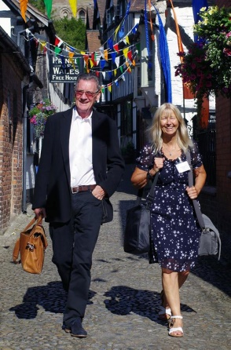
Hey this is fun! Brenda and Michael

INTERESTED IN EVENT MANAGING FOR THE FESTIVAL?
LEDBURY POETRY FESTIVAL
EVENT MANAGERS’ MORNING
Wed 22nd March, 2017
The Panelled Room
The Master’s House
HR8 1EA
9.30am – 12.30pm followed by complimentary lunch

Places are being taken now for this exciting morning. A chance to run-through current procedures, with fun and light hearted activities. Come along even if you are just interested in becoming an event manager to see what it entails. Existing managers, come and share best practice.
Remember: event managing does not necessarily include introducing the event! You can event manage without having to speak in front of a crowd!
http://www.poetry-festival.co.uk/volunteers/

Places are limited. Book by Weds 15th March, giving any dietary restrictions
Phillippa: manager@poetry-festival.co.uk
01531 636232
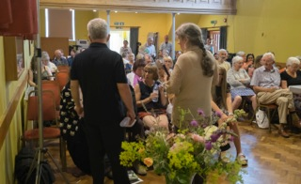
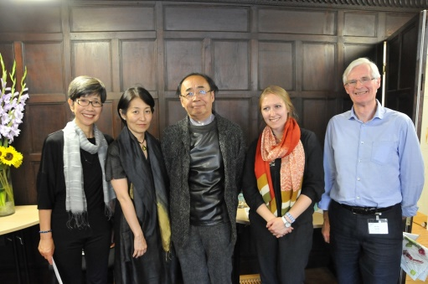
And this! Angela France with Ian McMillan at the Poetry Competition Winners' event
So is this! Alan Lloyd with Mikiro Saski and Masayo Koike

