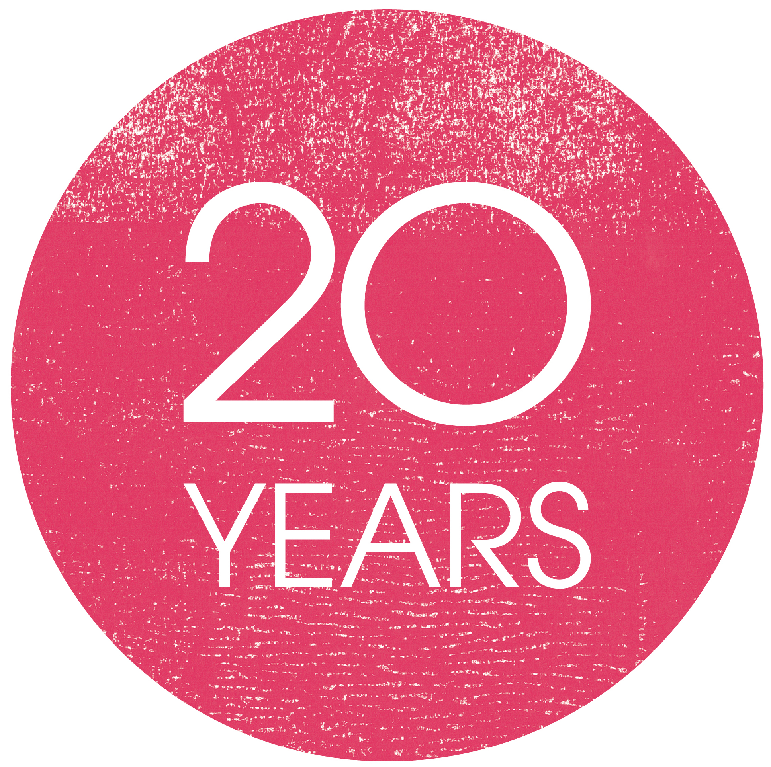Details for listing in
Ledbury Poetry Festival Programme Directory
1 - 10 July 2016
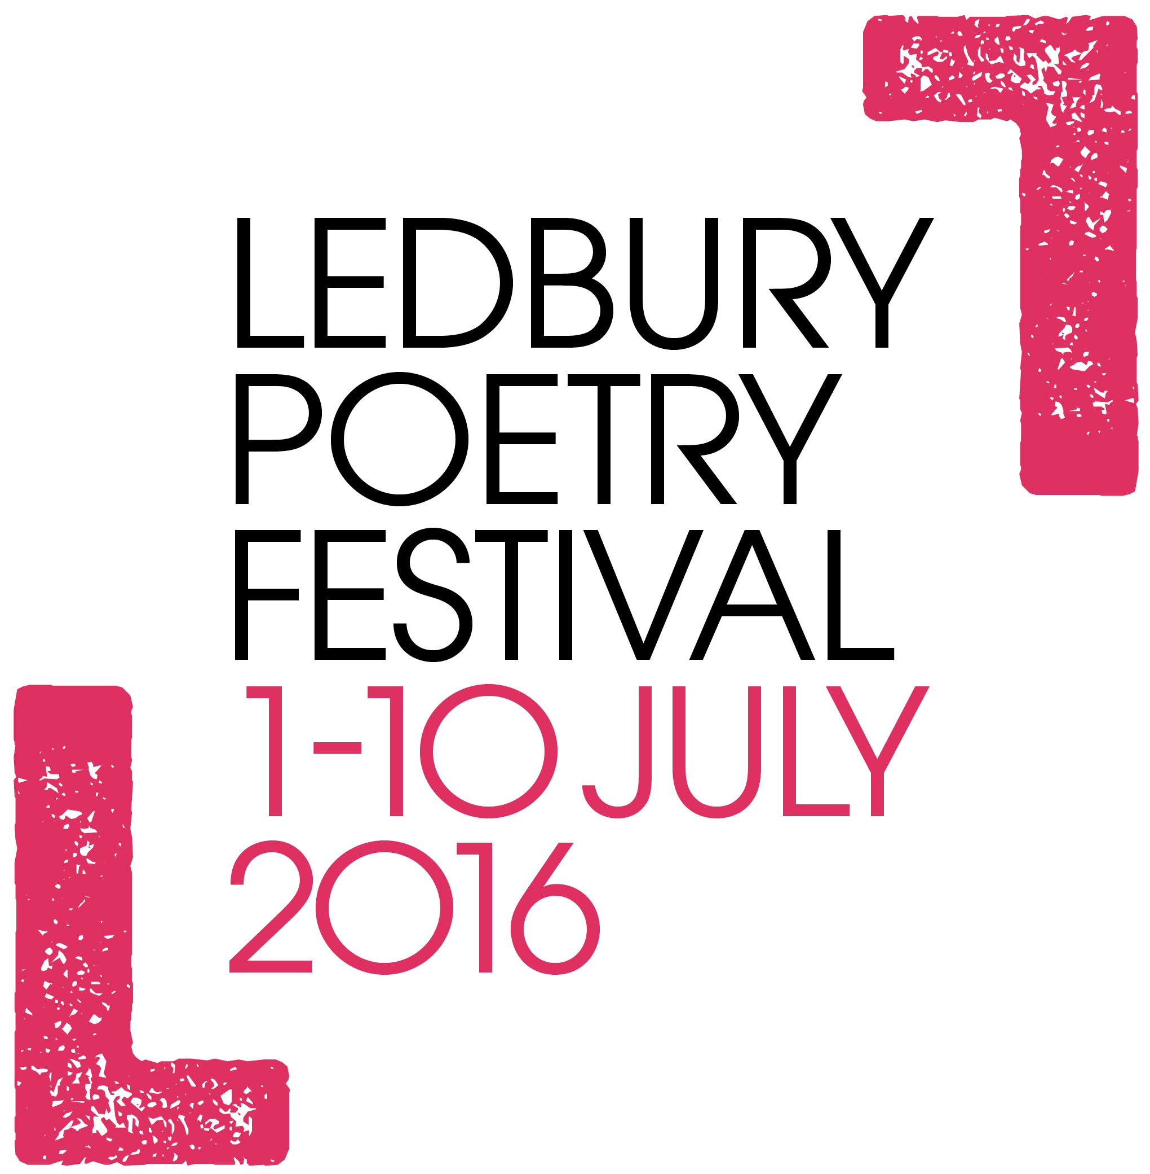Please keep entire listing within 40 words
(Unfortunately, due to demand for space, longer listings may need to be edited)
Name of organisation:
Contact name:
(optional)

Address:

Postcode:
Telephone number:

Email address:

Website:

Opening times:

Description of business/service offered:

Please return by Friday 18th March
Ledbury Poetry Festival, The Master’s House, Bye St, Ledbury HR8 1EA

Payment, please tick
⃝ £40 cash
⃝ £40 cheque payable to Ledbury Poetry Festival
⃝ BACS, please give your business name as a reference to:
Ledbury Poetry Festival Ltd, Sort Code: 40-24-11 Account: 91428616

Thank you!

