Details for listing in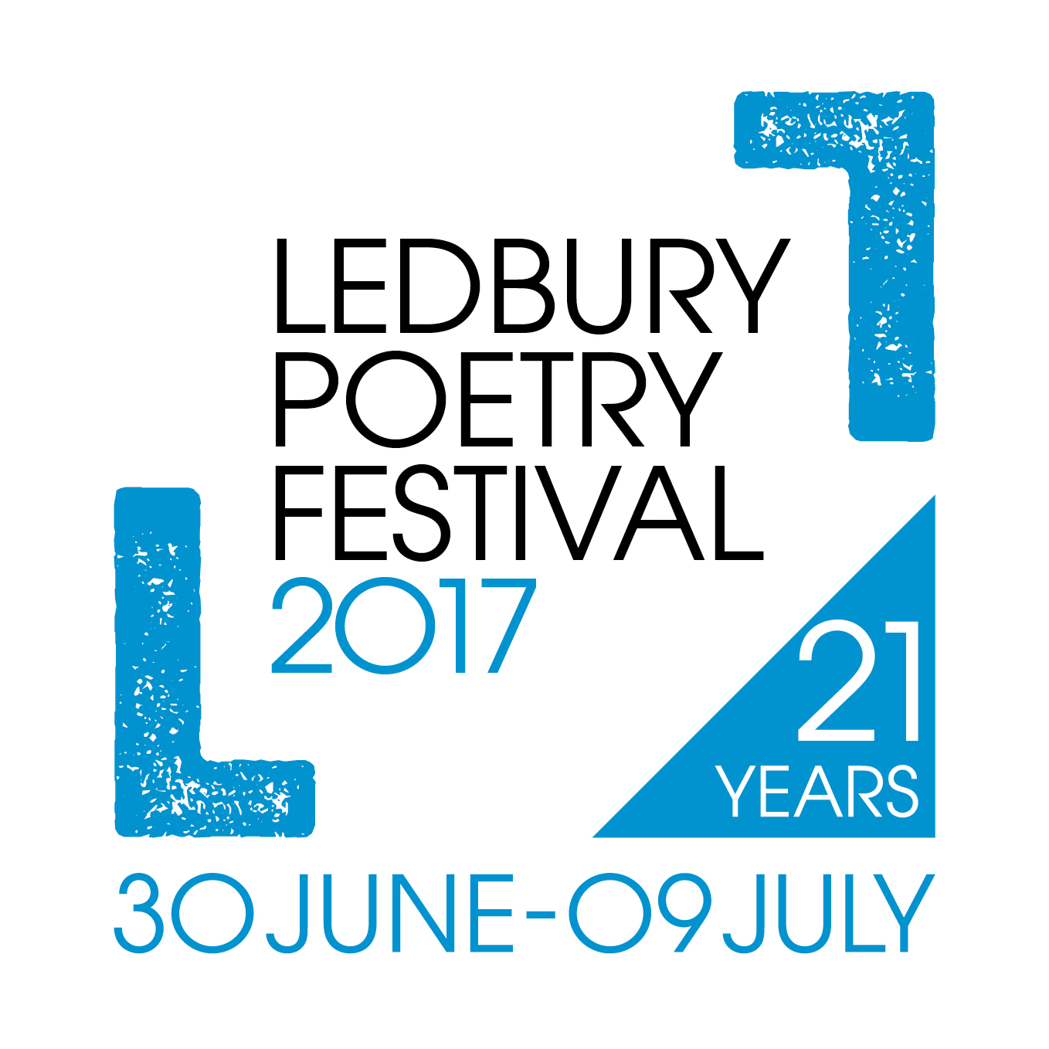
Ledbury Poetry Festival Programme Directory
30 June – 9 July 2017
Use the form as a guide and please keep entire listing within 40 words . You do not need to fill each space.
(Unfortunately, longer listings may need to be edited)

Name of organisation:
Contact name:
(optional)
Address:

Postcode:
Telephone number:
Email address:

Website:

Opening times:

Description of business/service offered:

Please return by Friday 17th March to manager@poetry-festival.co.uk
or Ledbury Poetry Festival, The Master’s House, Bye St, Ledbury HR8 1EA

Please DO NOT send payment. Due to printing restrictions we only have space for 30 listings. If you are one of the first 30 to respond, the Festival will invoice you for payment

Thank you!

